Open IAM

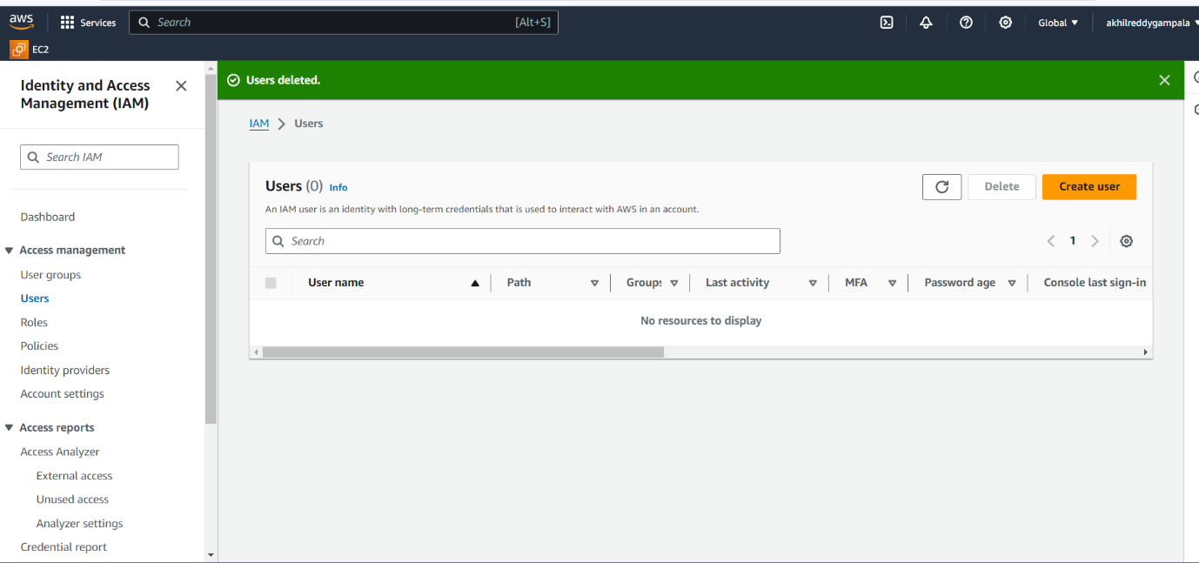

Give permission

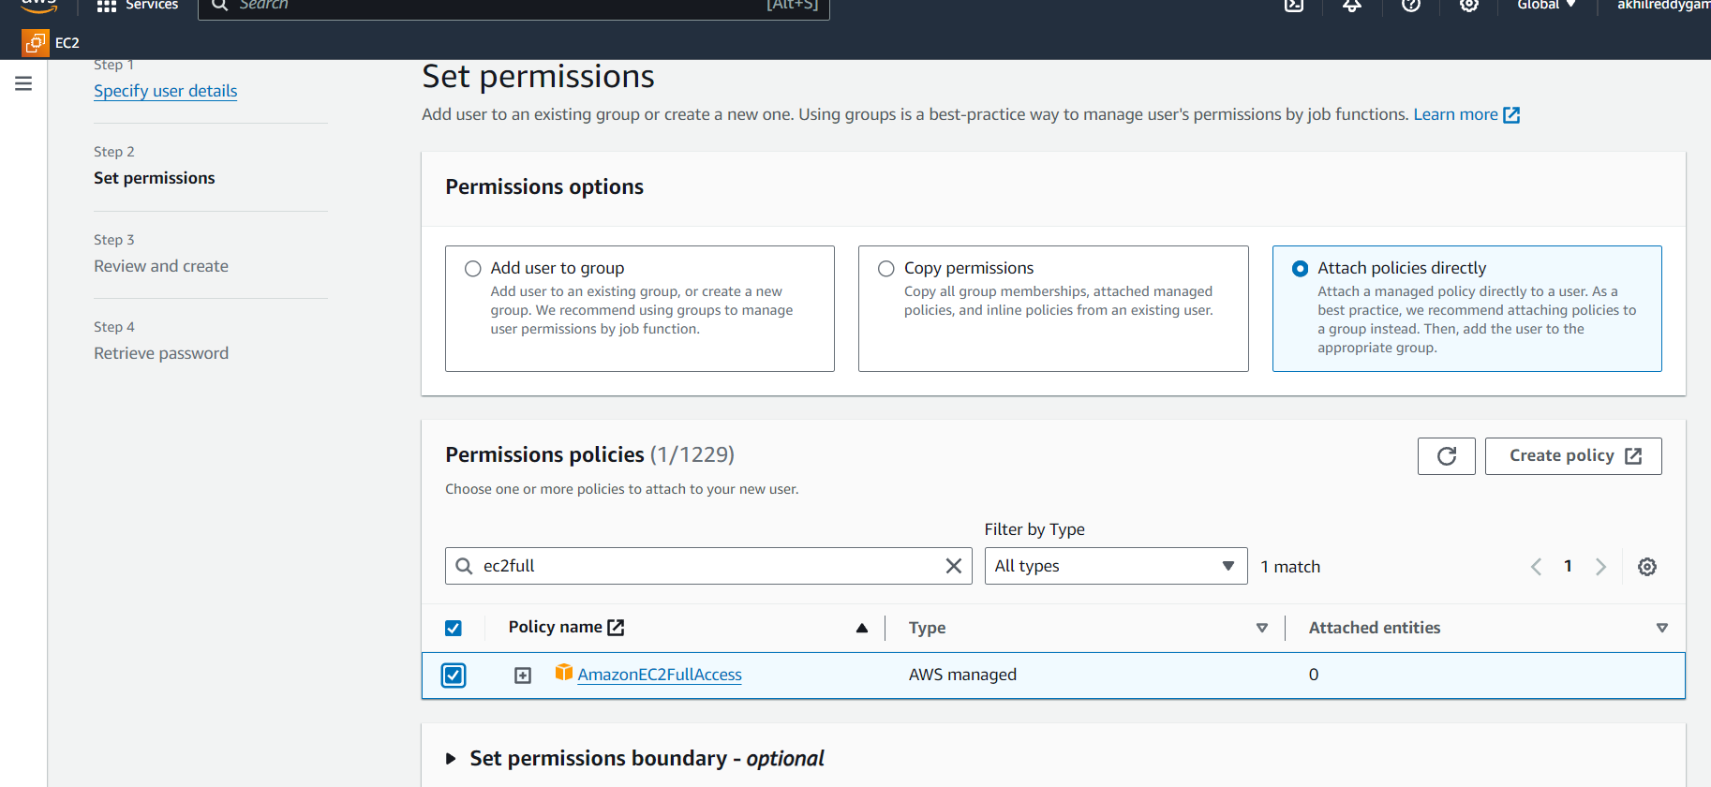

Create user IAM

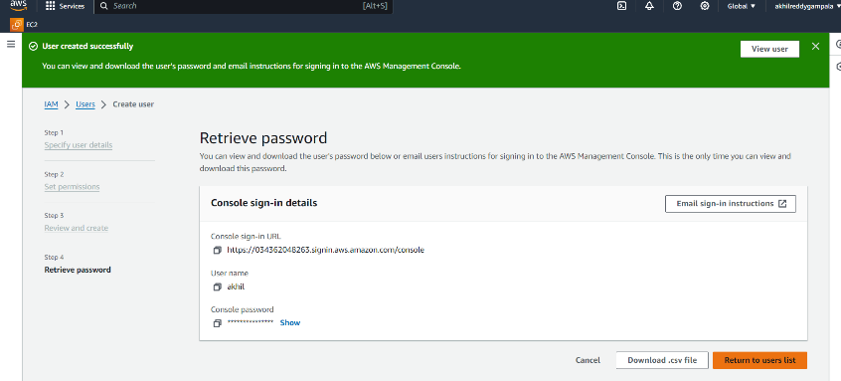

Open in new browser URL and login

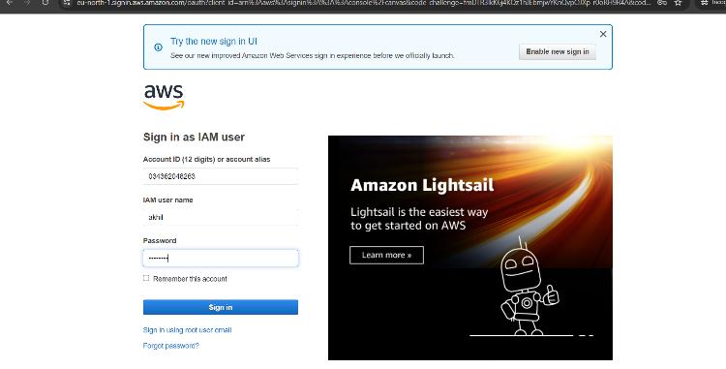

Open EC2 and launch instance and allow all traffic and add security group to all traffic

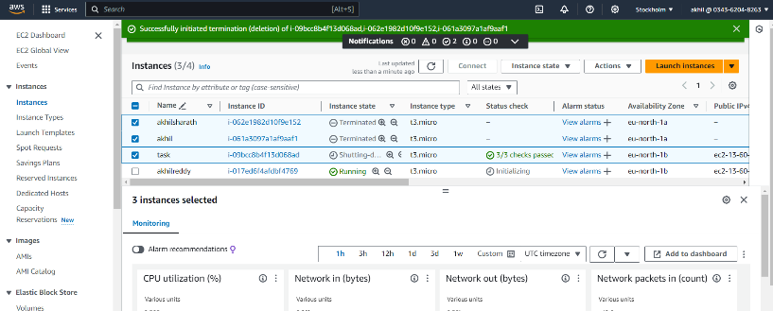

Next step Click on connect and choose ssh client and copy the example

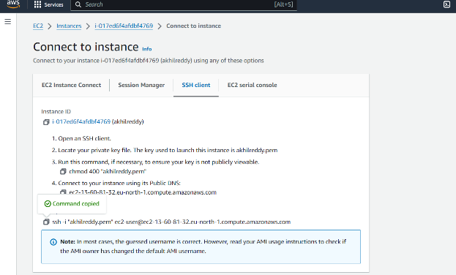

Open git bash in which folder you wanna do it and paste the command in git bash

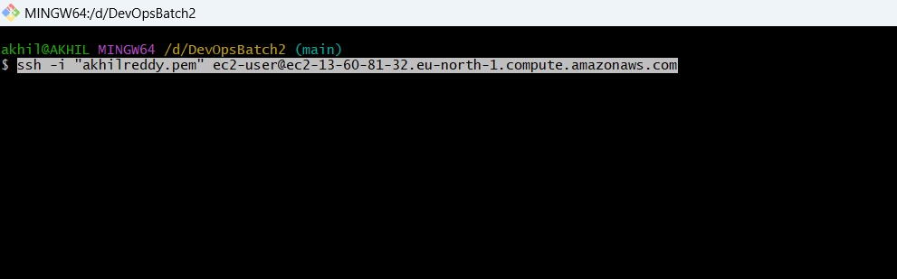

And install jenkin

Sudo su --- to go root user

* sudo yum update –y
* sudo wget -O /etc/yum.repos.d/jenkins.repo \

<https://pkg.jenkins.io/redhat-stable/jenkins.repo>

* sudo rpm --import <https://pkg.jenkins.io/redhat-stable/jenkins.io-2023.key>
* sudo yum upgrade
* sudo dnf install java-17-amazon-corretto -y
* sudo yum install jenkins -y
* sudo systemctl enable Jenkins
* sudo systemctl start Jenkins
* sudo systemctl status Jenkins

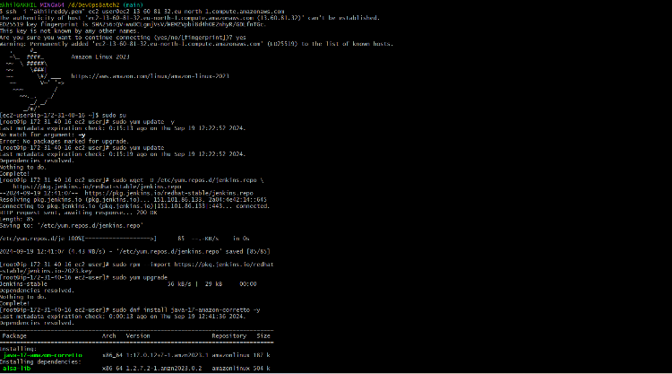

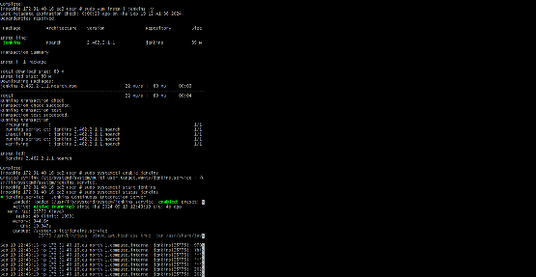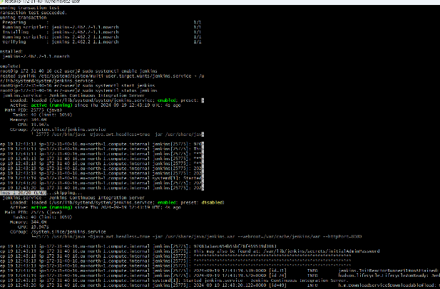

Next step go to IPV4 address

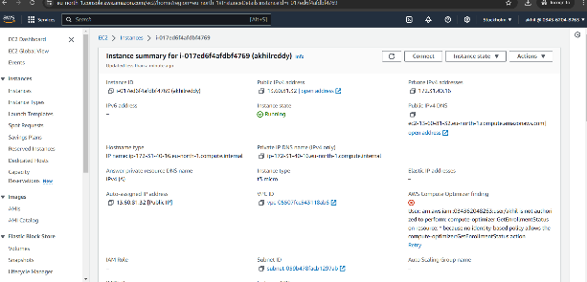

Paste IPV4 Address in new tab 🡪 :8080

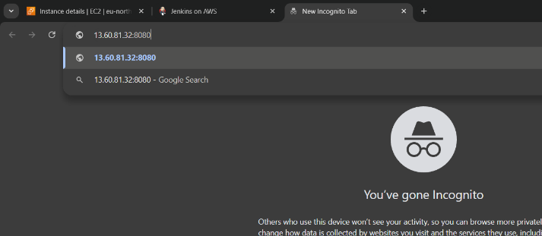

Unlock Jenkins password

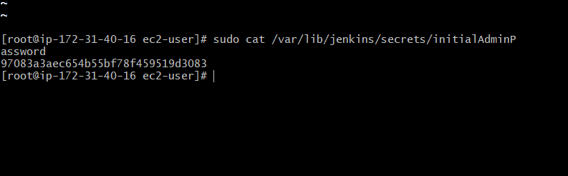

Install Jenkins plugins

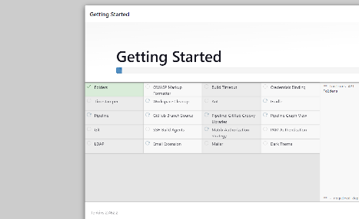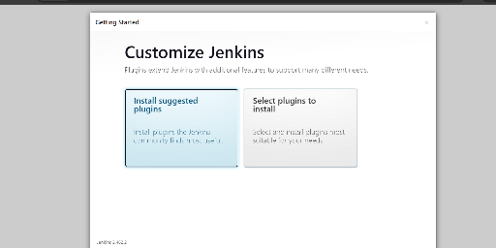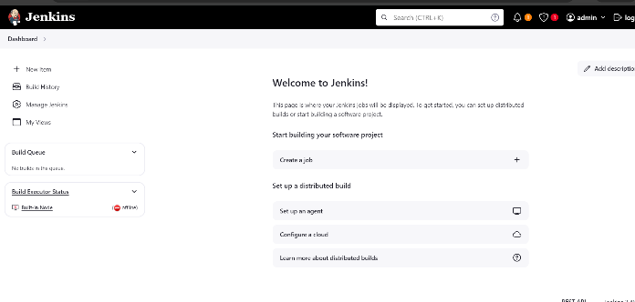

Next step go to git bash and press 🡪 yum install git

Git config –global user.email “mailid”

Git config –global user.name “name”

Git clone URL

LS -a 🡪 to check list

Cd Devopsbatch2/

Git push

Username—name

Pwd – pwd

To create password go to git hub dash board

Click on settings

Click on developer settings

Click on token

Click on generate new token

Git status 🡪 to check which branch

Now go to Jenkins page

Create new job

Select scm 🡪git

Give url in git

Check branch nane

Save and apply

Build now